Name: Ryan C. Elico Section: BSIT – 501

1. LOGGING IN

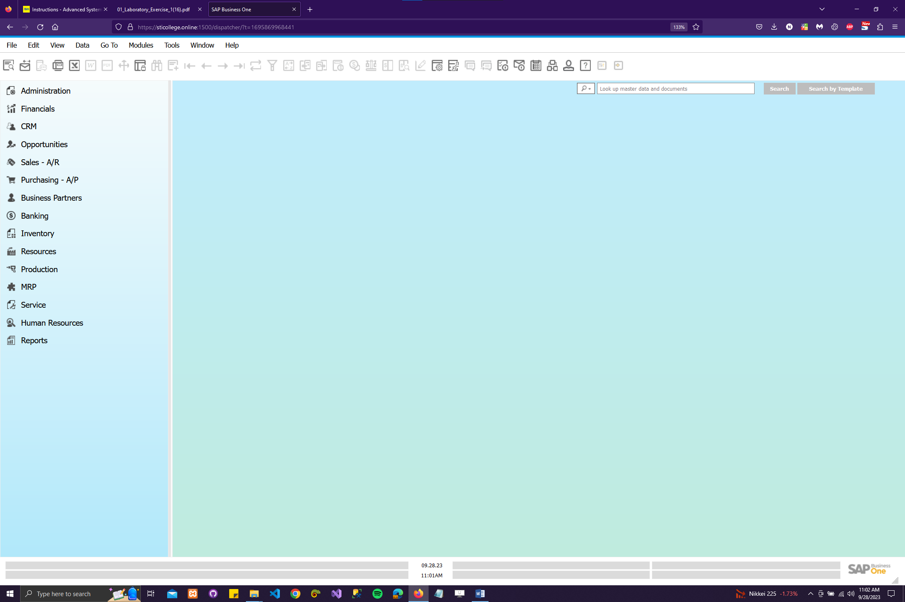

**Tool Bar**

**Modules**

**Menu Bar**

Caption: In the SAP Business One (SAP B1) process, I start by opening a web browser and entering the URL provided by my instructor. After that, I select the designated server and company, both of which are assigned by the instructor. Then, I log in using the specific user ID and password that corresponds to the branch I've been assigned to, making sure to set the default branch as instructed. Once logged in, I capture a screenshot of the SAP Business One main screen and proceed to identify and label the key components, including the Menu Bar, Tool Bar, and Module. Finally, I paste this output into my workbook for reference and documentation purposes. This ensures that I am ready to navigate and utilize SAP B1 effectively for my assigned tasks.

1. USER AND PASSWORD MAINTENANCE

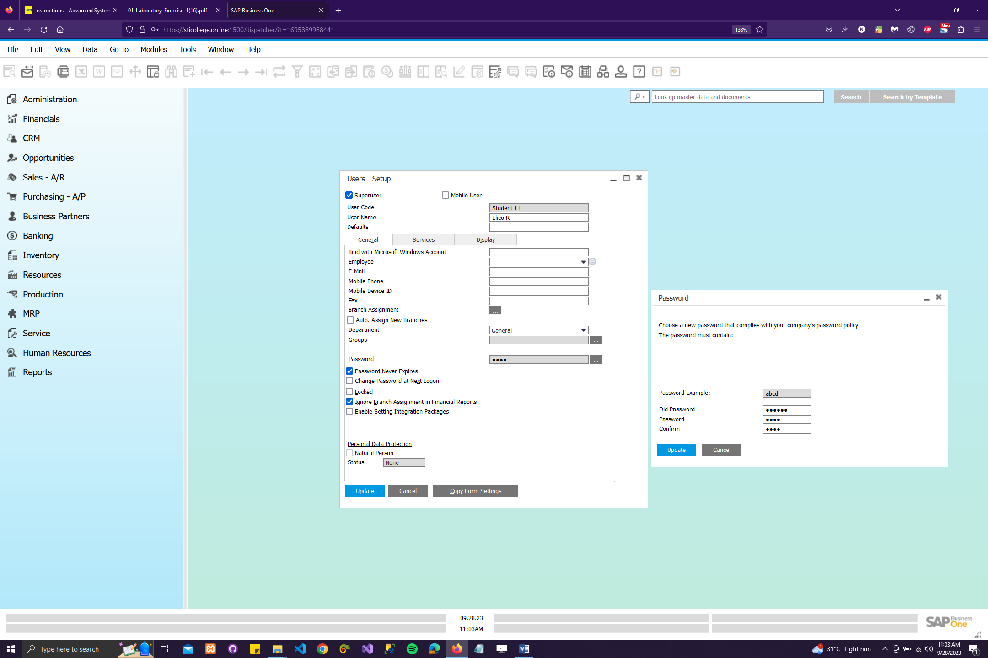

**Caption:** I start by maintaining my user and password settings. To do this, I click on the toolbar and select "My Personal Settings," which opens the user setup window. Inside this window, I change my username to my own name. Additionally, in the General tab, I customize my password by clicking next to the Password field. After making these changes, I capture screenshots of both the Users - Set up and Password windows for reference, and I paste them into my workbook, labeling it as "Password Maintenance" to ensure I have a record of my user and password settings in SAP B1.

1. BRANCH NAME SETTING

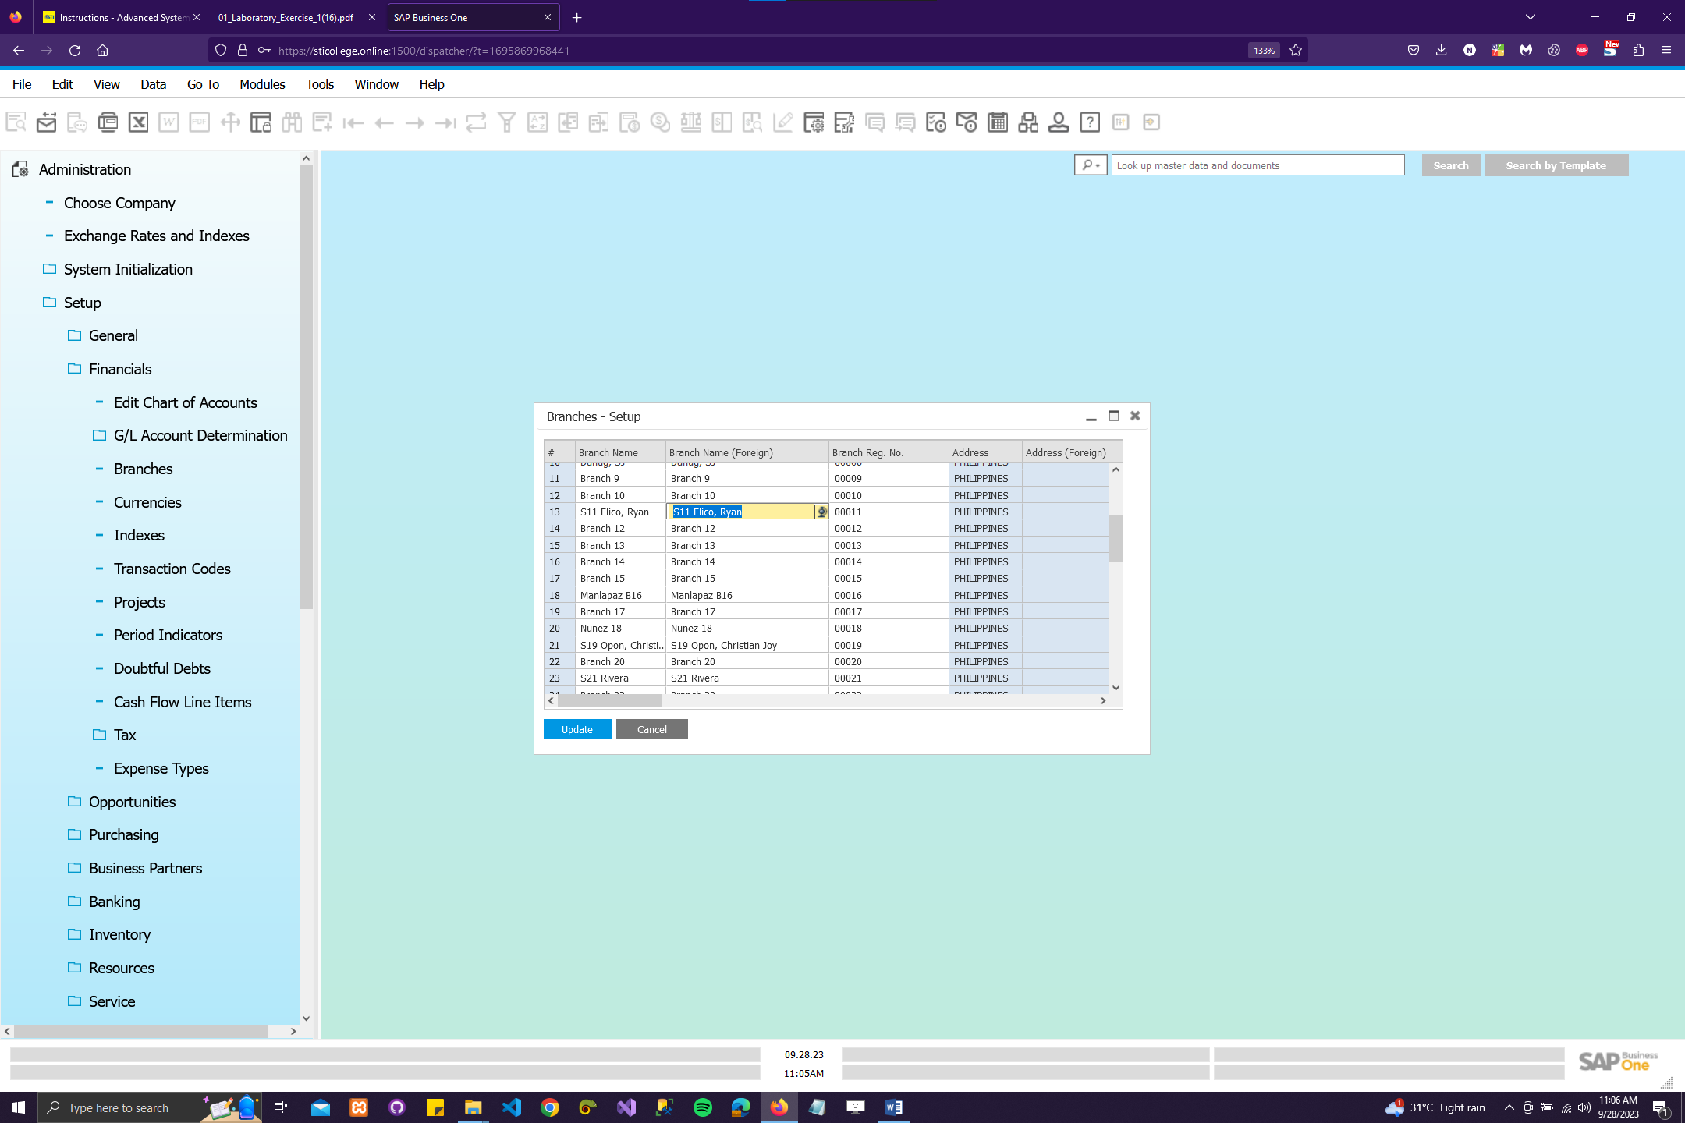

**Caption:** I begin by navigating to the Administration module and selecting Setup, followed by Financials, and finally Branches. After locating the branch assigned by my instructor, I proceed to modify the Branch Name and Branch Name (Foreign) fields with my own name. Clicking 'Update' finalizes the changes, and I capture this updated branch information to paste it into my workbook, duly labeled as "Branch Name Setting." This process ensures accurate and personalized branch information within the SAP B1 system.

1. LANGUAGE AND DISPLAY PARAMETERS

4.a - Set the Display Parameters

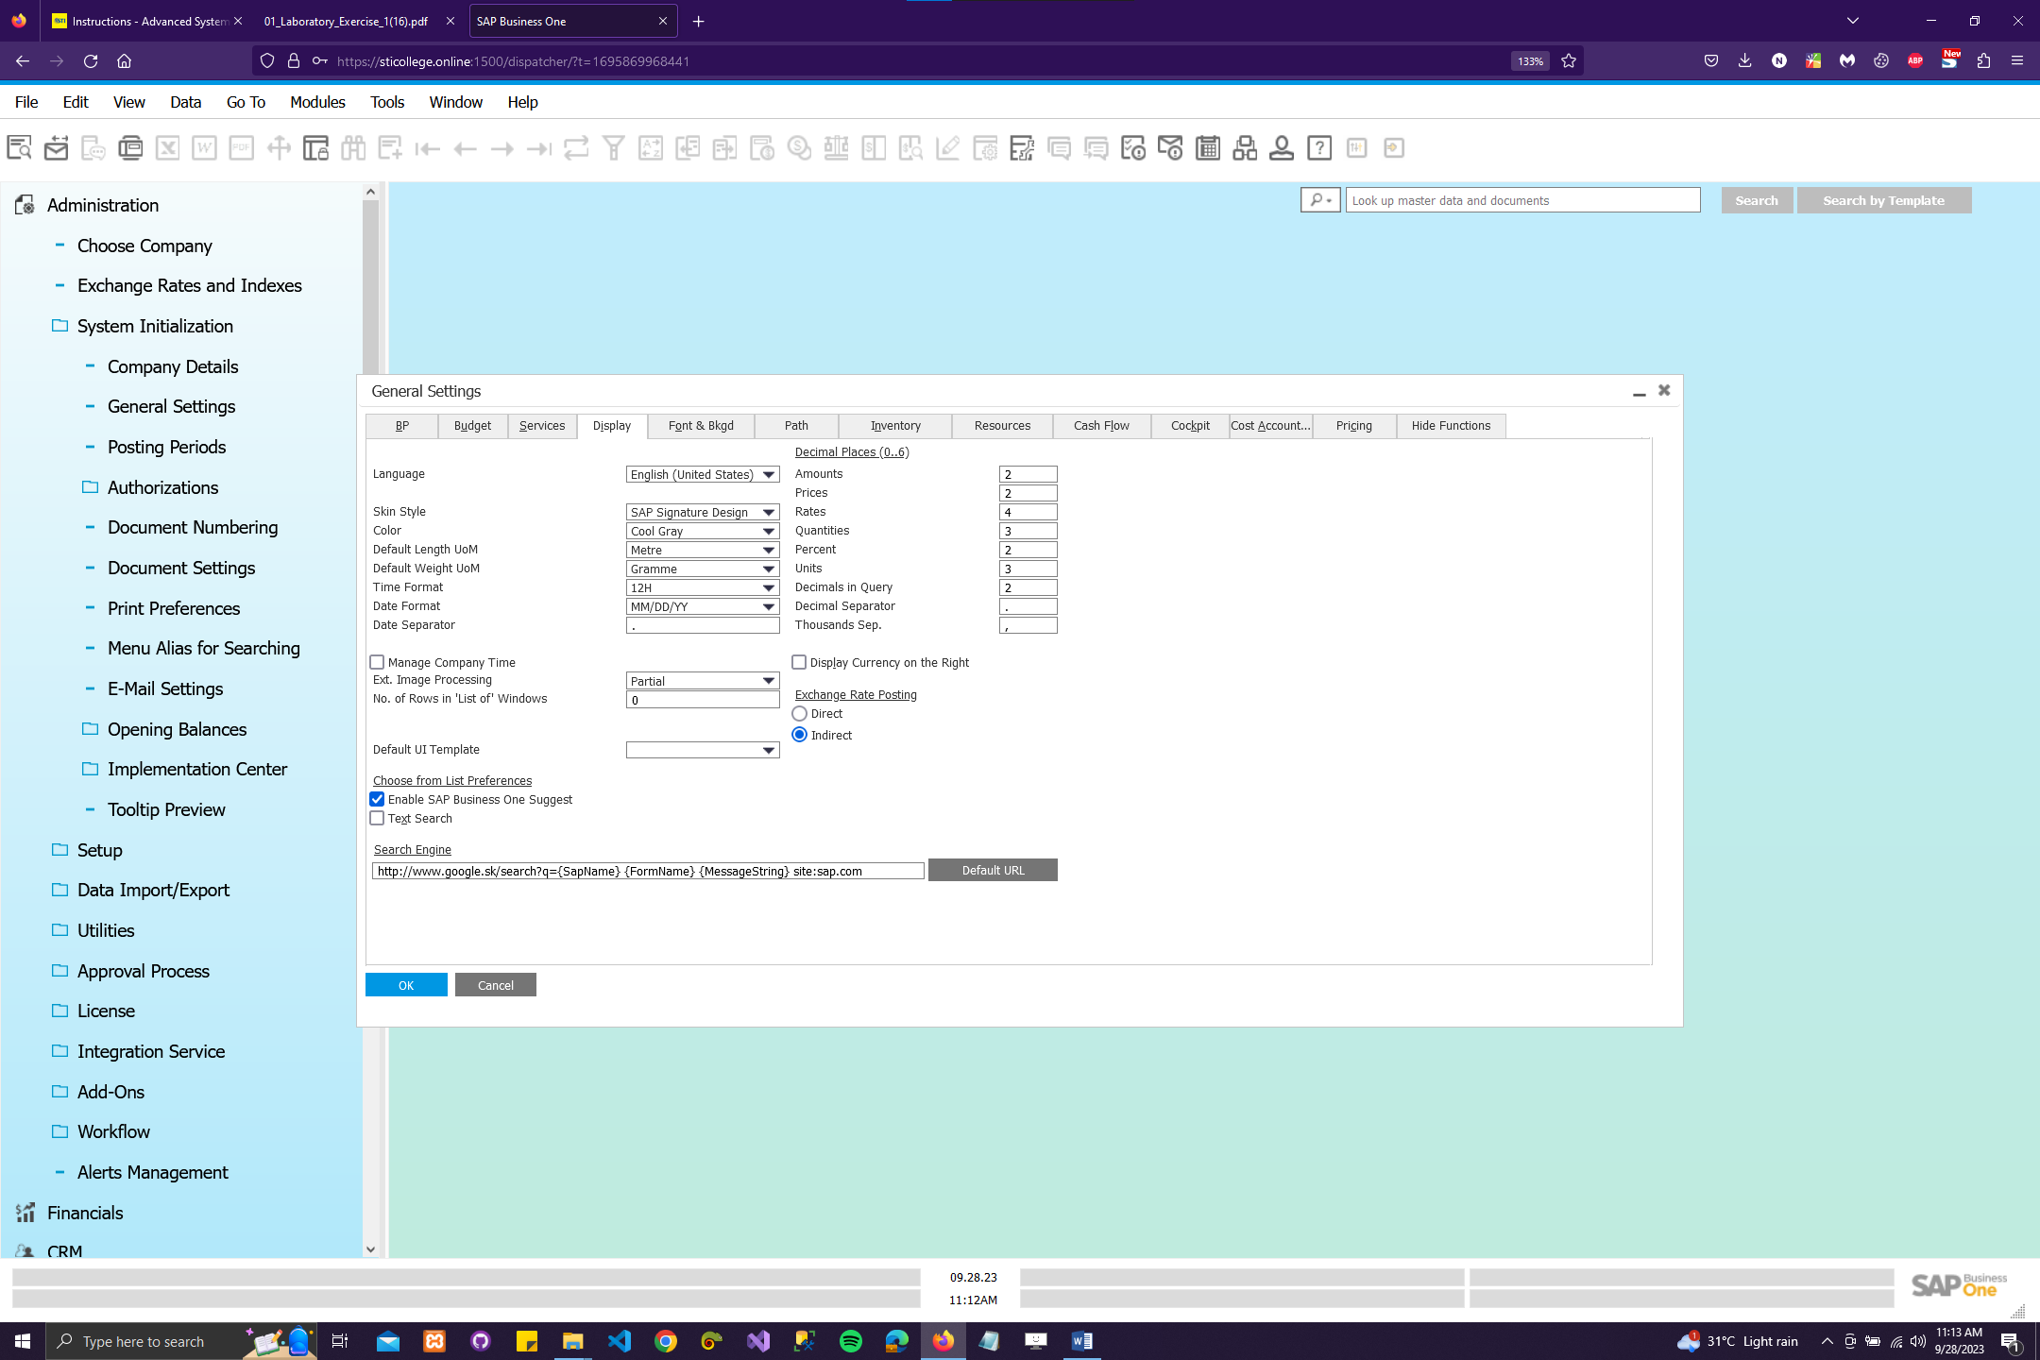

Caption: My process begins by configuring the display parameters. To do this, I navigate through the Main Menu, selecting Administration > System Initialization > General Settings from the Module. Next, I access the Display tab and input specific information: I set the Language to English (United States), choose the SAP Signature Design for Skin Style, opt for Cool Gray as the Color scheme, select a 12-hour Time Format, and set the Date Format to MM/DD/YY. Finally, I click the "Update" button to save these settings, ensuring not to close the window to complete this crucial configuration step efficiently.

4.b - Set the Font and Background

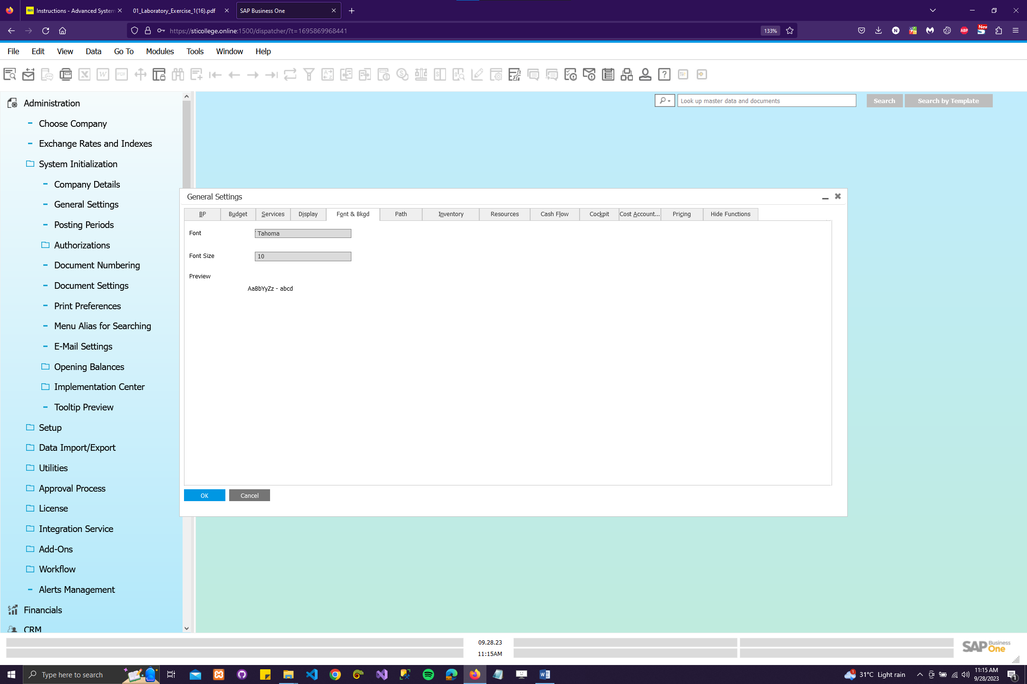

Caption: I start by customizing the interface to suit my preferences. To do this, I navigate to the Display tab within SAP B1 and proceed to adjust the font style, font size, background, and image display settings according to my liking. After making these modifications, I ensure that I select the "Update" option to apply the changes, and then I confirm the changes by clicking "OK." To document these adjustments, I capture a screenshot of my customized SAP Business One interface, showcasing the new font and background settings, and paste it into my document file for reference.

1. Describe the interface of SAP Business One. How does this kind of interface enable organizations to perform their daily business tasks?

Answer: In SAP Business One, the interface is designed with user-friendly efficiency in mind. As a student, I interact with SAP B1 through its intuitive graphical user interface (GUI), which presents a unified and streamlined workspace for managing various business processes. This interface enables organizations to seamlessly perform their daily business tasks by providing easy access to critical functionalities such as financial management, inventory control, sales, and customer relationship management. Through customizable dashboards and clear navigation menus, users like me can swiftly access real-time data, generate reports, and make informed decisions. The interface's integration capabilities also allow for smooth coordination across departments, promoting collaboration and optimizing overall business operations. SAP B1's interface is a powerful tool that empowers students and professionals alike to efficiently manage and enhance business processes within their organizations.

1. Describe and explain the part of the menu bar and navigation tools in SAP Business One. Why do you think SAP Business One came up with this kind of design?

Answer: In SAP Business One, the menu bar and navigation tools play a pivotal role in streamlining business processes. At the heart of the software, the menu bar serves as the gateway to various modules, from financials to inventory management and beyond. It offers a hierarchical structure that organizes functions logically, allowing users to access specific tasks with ease. The navigation tools, including the home button and breadcrumbs, provide efficient ways to move between screens and maintain context. This design is rooted in enhancing user productivity and reducing the learning curve. SAP Business One aims to cater to a diverse user base, from small business owners to enterprise-level organizations, making it imperative to create an intuitive and efficient interface that empowers users to manage their operations effectively. The menu bar and navigation tools exemplify SAP's commitment to user-friendliness and accessibility, enabling students and professionals alike to harness the full potential of this powerful ERP system.